Amit Graduation Project

|Smart Home Project|

Project Done by:   
**Mirna Sherif Mohamed Salama   
Group C42**

*Date: 13/12/2020*

# Abstract

In this project, you will find the conclusion of what I learned in the interface course. It is a smart home project, Bluetooth based, meaning that it can be controlled using a smart phone application. The objective is to control mainly 3 units, a room light system, room curtains (DC Motor) and a temperature sensor display.

Table of Contents

Abstract 2

Introduction 4

PROJECT LAYOUT 4

USART CONNECTION 4

SPI CONNECTION 5

THE SLAVE MICRO CONTROLLER 6

1.DC motor that rotates 2 two directions to open/shut down a curtain………. 6

2.A room light system (**ON/OFF** switches)……….. 6

3.A temperature sensor display………… 6

# Introduction

The idea of the project is to use a master microcontroller to control one or more slave microcontroller. In my project I am using only one slave microcontroller

## PROJECT LAYOUT

The Bluetooth module (that transfers the data from smartphone) communicates with the master microcontroller via USART connection

## USART CONNECTION

The master microcontroller communicates with the slave via SPI connection

## SPI CONNECTION

SPI CONNECTION

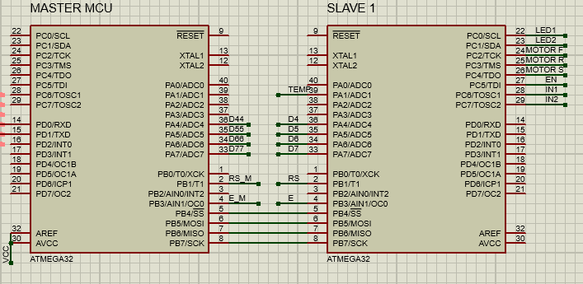

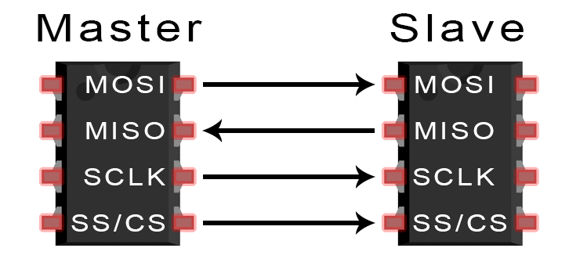

## THE SLAVE MICRO CONTROLLER

It controls:

### Smart curtain and blind - What are the smart curtain/blind advantages?DC motor that rotates 2 two directions to open/shut down a curtain

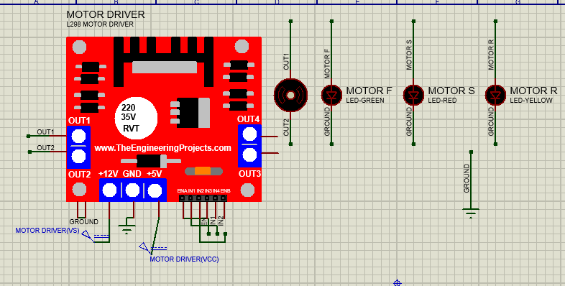

### Light Bulb On Off Images, Stock Photos & Vectors | ShutterstockA room light system (**ON/OFF** switches)

### A temperature sensor display